**PROJECT REPORT TEMPLATE**

1. INTRODUCTION
   1. Overview
   2. Purpose
2. PROBLEM DEFINITION & DESING THINKING
   1. Empathy Map
   2. Ideation & Brainstorming Map
3. RESULT

* 1. Data Model:
  2. Activity & Screenshot

1. ADVANTAGES & DISADVANTAGES
2. APPLICATIONS
3. CONCLUSION
4. FUTURES

1. **INTRODUCTION**

**1.1 Overview**

Uber Technologies, Inc. (commonly referred to as Uber) provides ride-hailing services, food delivery, and freight transport. It is headquartered in San Francisco and operates in approximately 70 countries and 10,500 cities worldwide.

**1.2 Purpose**

**Uber is a transportation company with an app that allows passengers to hail a ride and drivers to charge fares and get paid. More specifically, Uber is a ridesharing company that hires independent contractors as drivers.**

We are a tech company that connects the physical and digital worlds to help make movement happen at the tap of a button. Because we believe in a world where movement should be accessible. So you can move and earn safely.

**2. PROBLEM DEFINITION & DESIGN THINKING**

**2.1 Empathy map**

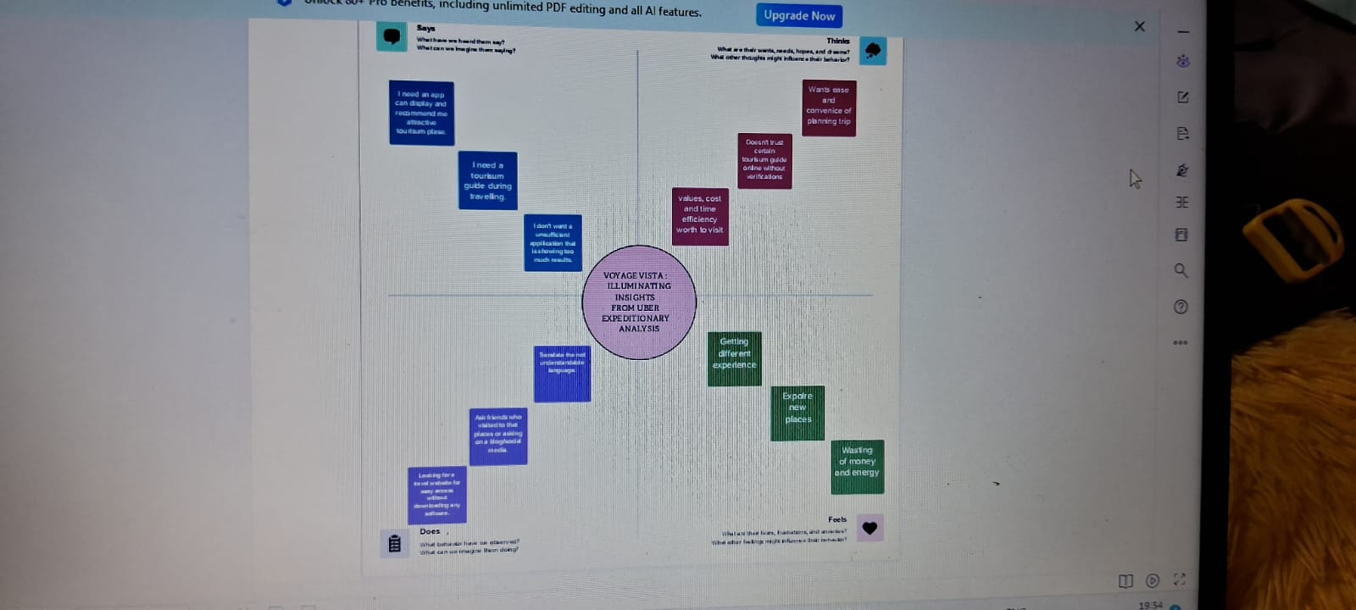

**2.2 Ideation & Brainstorming map**

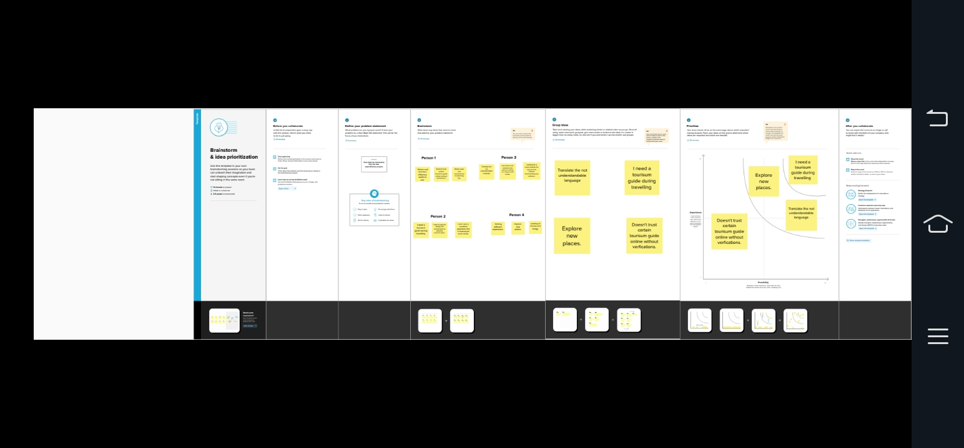

1. **RESULT**

**3.1 Data Model:**

|  |  |
| --- | --- |
| Object name | Fields in the object name |
| 1. Date | Number |
| 1. Description | Text |
| 1. Amount | Number |
| 1. Category | Text |
| 1. Payment Method | Text |
| 1. Receipt/Attachment | Text |
| 1. Notes | Text |

**3.2 Activity & screenshots**

**Milestone 1: Define Problem / Problem Understanding**

Activity 1: Specify the business problem

Refer Project Description.

Activity 2: Business requirements

Driver Performance Evaluation: Determine the criteria for evaluating driver

performance,

such as customer ratings, completion rate, cancellation rate, average trip duration,

and driver feedback. These metrics can help identify top-performing drivers and areas

for improvement.

Efficiency Analysis: Assess driver efficiency by analyzing metrics such as average

time spent waiting for passengers, average distance driven per trip, and idle time

between trips.

This analysis can help identify opportunities to optimize driver utilization and

reducedowntime.

Supply and Demand Analysis: Understand the relationship between driver supply

and passenger demand in different areas and at different times. Identify peak hours

and high-

demand areas to optimize driver allocation and increase customer satisfaction.

Route Optimization: Analyze driver routes and identify patterns to optimize

navigation and

reduce travel time. By analyzing historical trip data and using mapping algorithms,

you can suggest more efficient routes to drivers, enhancing their performance and

reducing fuel costs.

Activity 3: Literature Survey (Student Will Write)

A literature survey conducted by students exploring YouTube channels would

typically involve researching existing studies, academic papers, and

publications related to the topic

**Milestone 2: Data Collectionm & Extraction**

Data collection is the process of gathering and measuring information on variables of interest, in an established systematic fashion that enables one to answer stated research questions, test hypotheses, evaluate outcomes and generate insights from the data.

**Activity 1: Downloading the dataset**

https://www.kaggle.com/code/mohamed08/exploratory-data-analysis-for-uber-trips/input

use the link to download the dataset

**Activity 1.1: Understand the data**

Data contains all the meta information regarding the columns described in the CSV

files. We have provided a csv file.

Column Description for Uber Drives- 2016.csv

● START_DATE: 2 JAN 2016 – 1 JAN 2017.

● END_DATE: 2 JAN 2016 – 1 JAN 2017.

● START: Cary, New York, Durham, Downtown, Midtown, Midtown East, Houston,

Gulfton, Whitebridge, Houston, Morrisville and 798 Others.

● STOP: Cary, New York, Durham, Downtown, Midtown, Midtown East, Houston,

Gulfton, Whitebridge, Houston, Morrisville and 798 Others.

● Miles Covered: 0.5-1220.92

● Purpose: Meeting, Temporary Site, Customer Visit, Meal/EntertainErrand/Supplies, Airport, Between Offices, charity, commute, moving

**Activity 2: Connect Dataset with Tableau**

Add the data set file in the text option and the data set will be connected

Milestone 3: Data Preparation

**Activity 1: Prepare the Data for Visualization**

This process helps to make the data easily understandable and ready for creating visualizations to gain insights into the performance and efficiency.

**Milestone 4: Data Visualization**

Data visualization is the process of creating graphical representations of data to help people understand and explore the information. The goal of data visualization is to make complex data sets more accessible, intuitive, and easier to interpret. By using visual elements such as charts, graphs, and maps, data visualizations can help people quickly identify patterns, trends, and outliers in the data.

**Activity 1: No of Unique Visualizations**

The number of unique visualizations that can be created with a given dataset. Some common types of visualizations that can be used to analyse the performance and efficiency of banks include bar charts, line charts, heat maps, scatter plots, pie charts, Maps etc.

**Activity 1.1 : Category and purpose analysis**

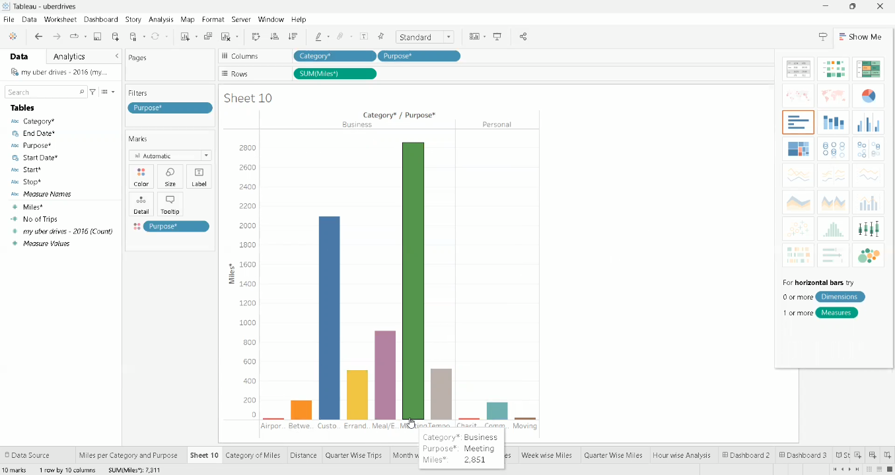

* Drag the category and purpose into the column
* Then drag the Miles into the row

**Activity 1.2 : Category analysis**

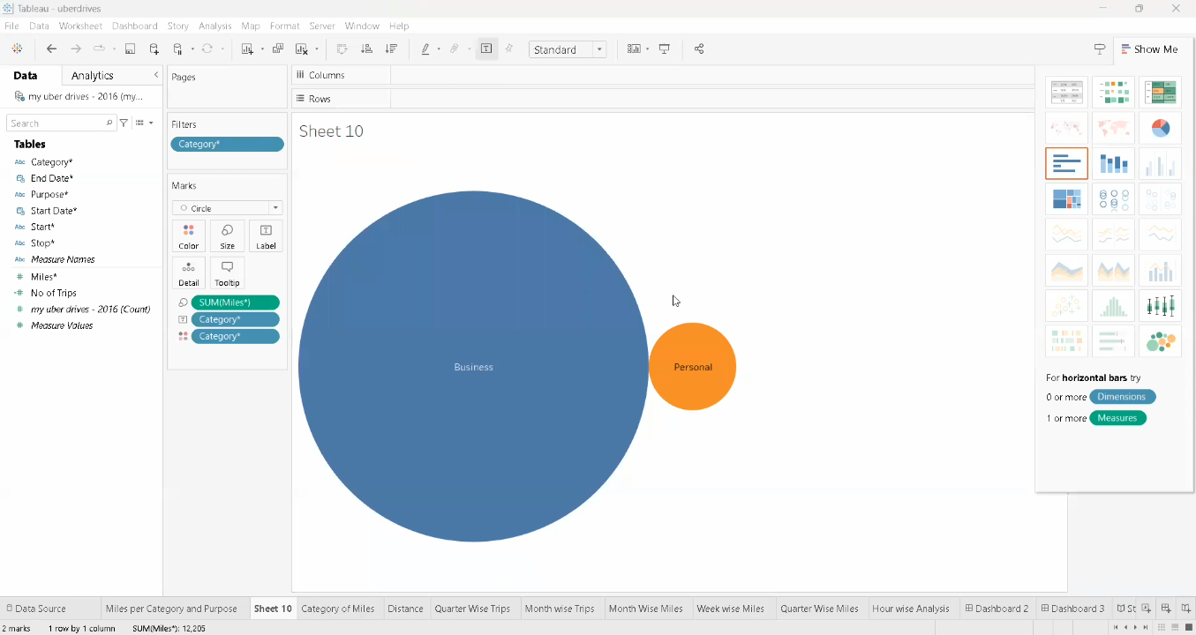

* Drag the category into the column
* Then drag the Miles into the row

**Activity 1.3 : Month wise Uber miles analysis**

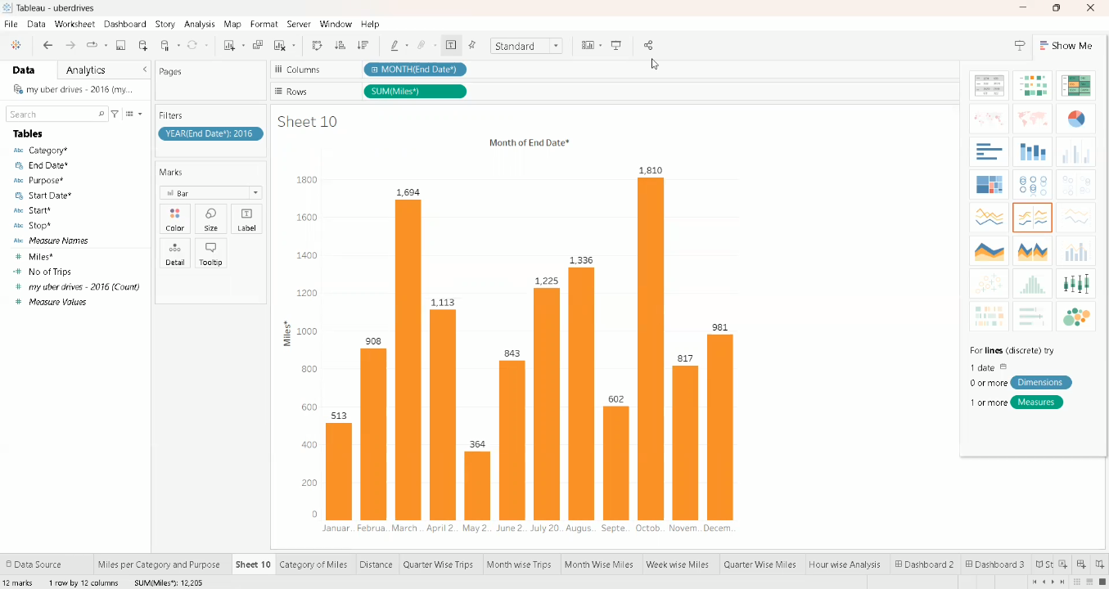

* Drag the End date (month) into the column
* Then drag the Miles into the row

**Activity 1.** **4 : week wise Uber miles analysis**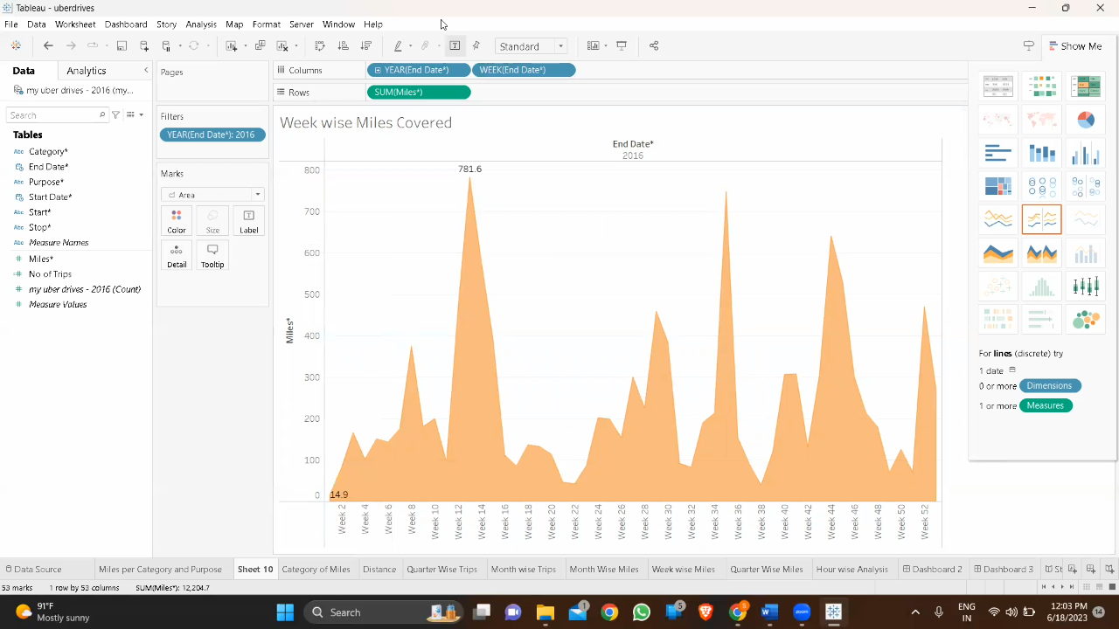

* Drag the End date (week) into the column
* Then drag the Miles into the row

**Activity 1.5 : Quarter wise Uber miles analysis**

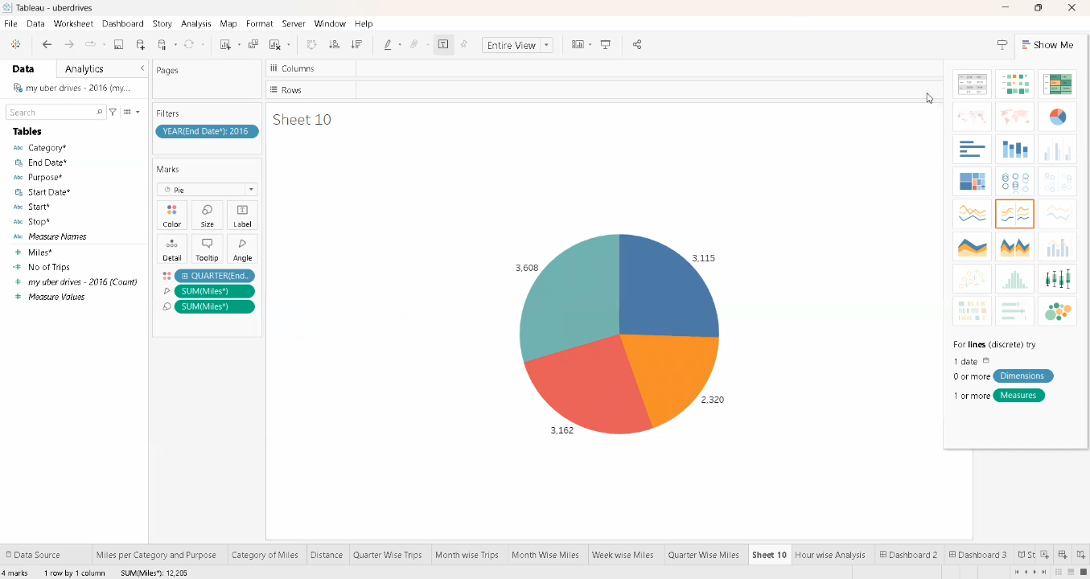

* Drag the End date (Quarter)into the column
* Then drag Miles the into the row

**Activity 1.6 : month wise Uber trips analysis**

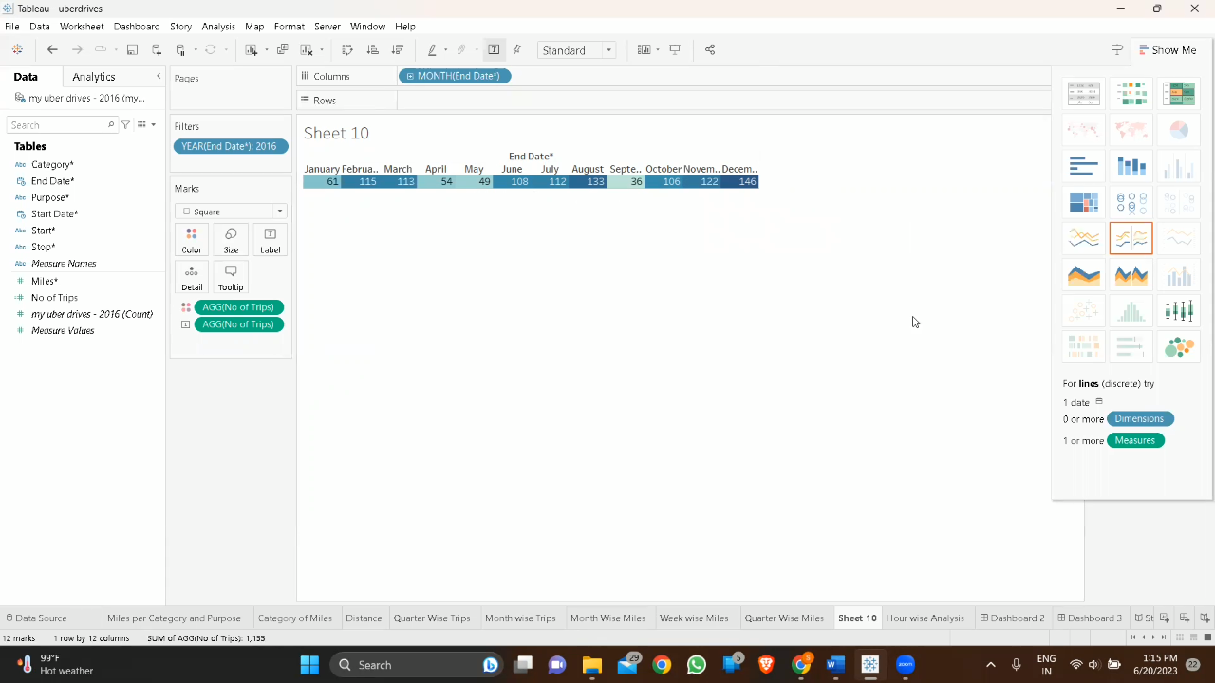

* Drag the End date (month) into the column
* Then drag the Number of Trips into the row

**Activity 1.7 : Quarter wise Uber trips analysis**

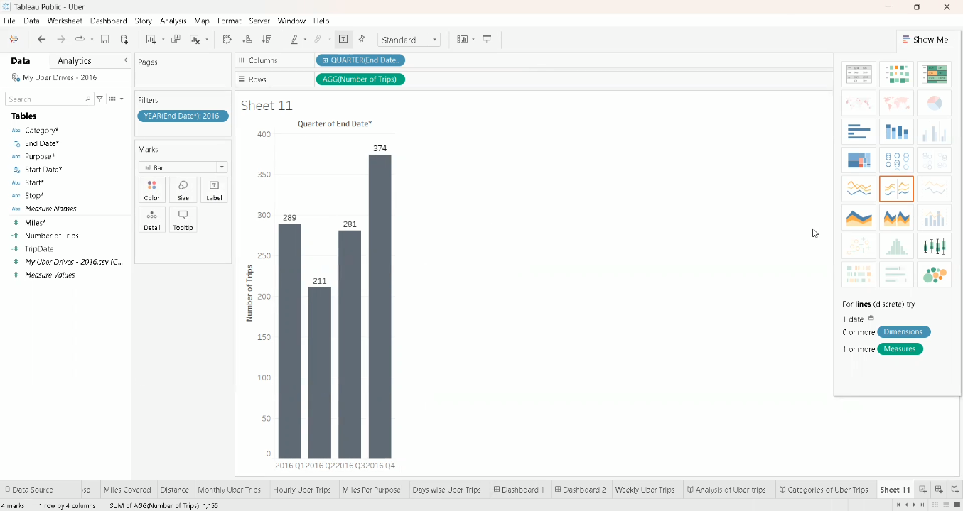

* Drag the End date (Quarter) into the column
* Then drag Number of Trips into the row

**Activity 1.8 :Hour wise Uber trips analysis**

* Drag the End date(Hours) into the column
* Then drag the Number of Trips into the row

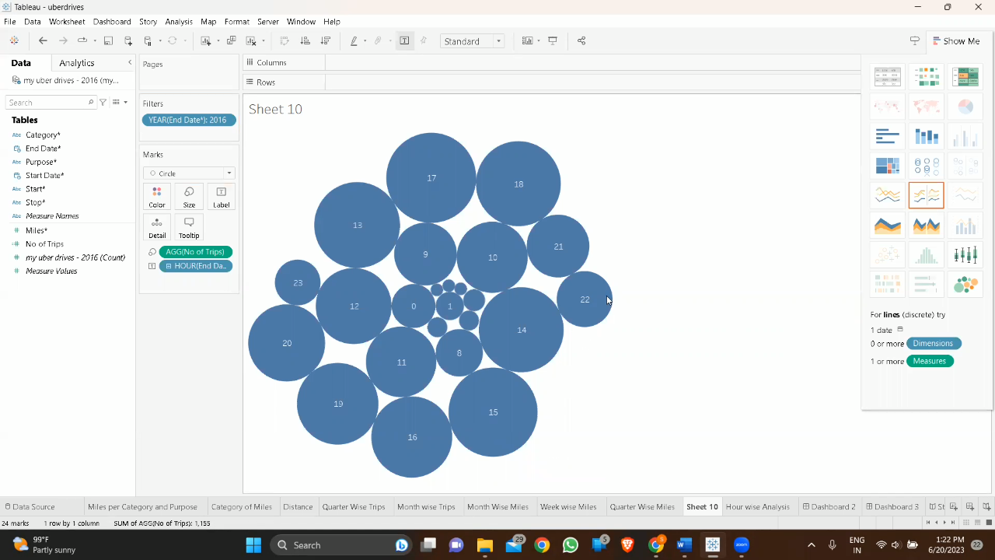

**Milestone 5: Dashboard**

A dashboard is a graphical user interface (GUI) that displays information and data in an organized, easy-to-read format. Dashboards are often used to provide real-time monitoring and analysis of data and are typically designed for a specific purpose or use case. Dashboards can be used in a variety of settings, such as business, finance, manufacturing, healthcare, and many other industries

**Activity 1: Responsive and Design of dashboard**

Once you have created views on different sheets in Tableau, you can pull them into a dashboard.

**Activity 1.1: Dashboard 1**

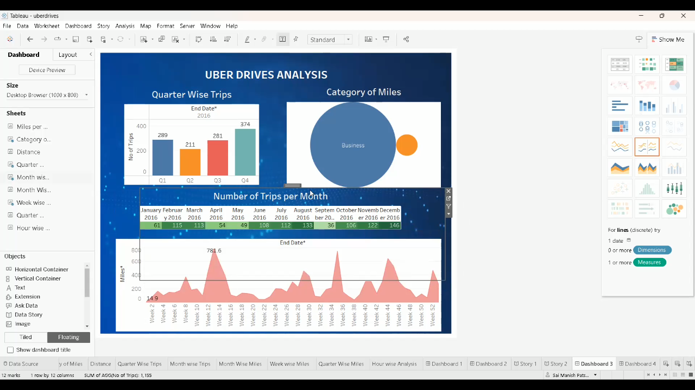

Activity 1.2: Dashboard 2

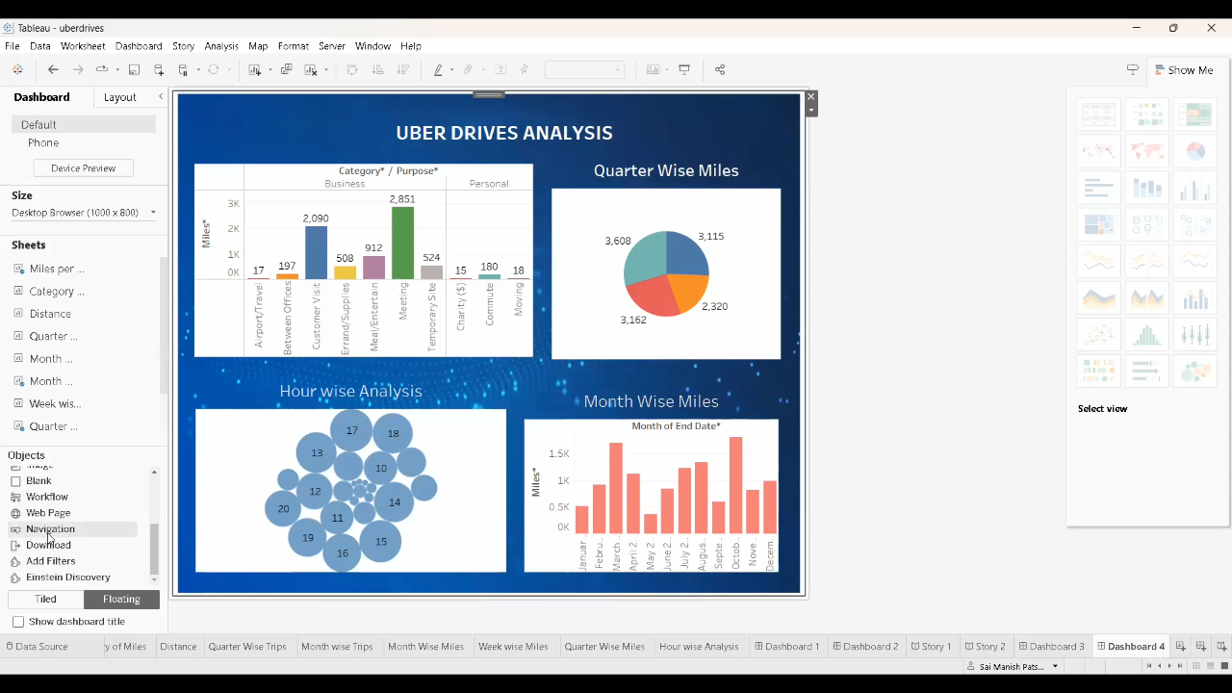

**Milestone 6: Story**

A data story is a way of presenting data and analysis in a narrative format, intending to make the information more engaging and easier to understand. A data story typically includes a clear introduction that sets the stage and explains the context for the data, a body that presents the data and analysis logically and systematically, and a conclusion that summarizes the key findings and highlights their implications. Data stories can be told using a variety of mediums, such as reports, presentations, interactive visualizations, and videos.

**Activity 1: Number of scenes in a story**

The number of scenes in a storyboard for a data visualization analysis of the performance of banks will depend on the complexity of the analysis and the specific insights that are trying to be conveyed. A storyboard is a visual representation of the data analysis process and it breaks down the analysis into a series of steps or scenes.

**Activity 1.1 : Story 1**

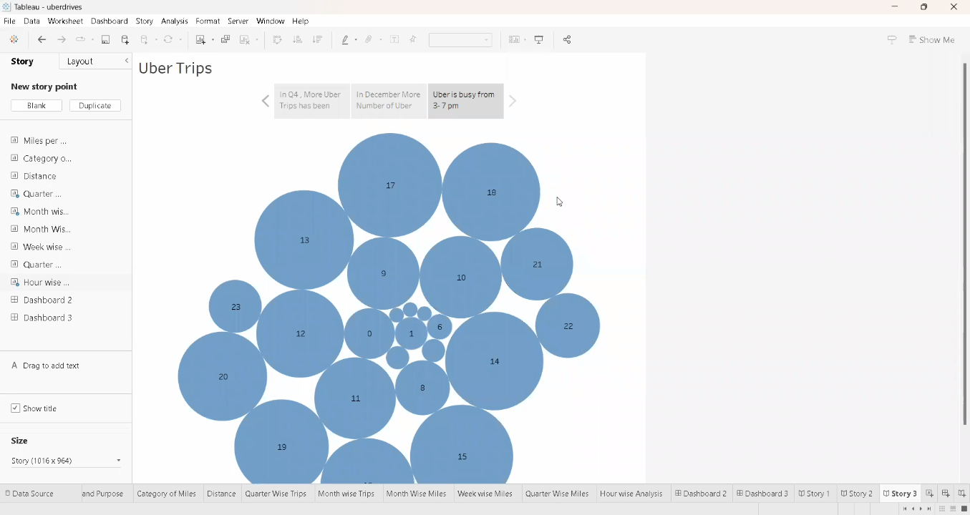

**Milestone 7: Performance Testing**

**Activity 1: Amount of Data Rendered to Tableau**

● The amount of data that is rendered to a Tableau depends on the size of the dataset

**Activity 2: Number of calculation fields**

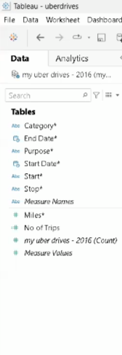

**Activity 3: Number of visualizations**

1. Bar graph showing Purpose of Uber with Miles covered.

2. Bubble chart showing distribution of Miles with Category.

3. Bar graph showing Quarter with Number of Trips

4. Highlight Table shows Month with Number of Trips.

5. Bar graph showing Month with Miles.

6. Area Chart showing Week with Miles.

7. Pie chart showing Quarter with Miles.

8. Bubble Chart showing Hour with Number of Trips.

9. Tree Map showing Distance between the Start and Stop Locations.

**Milestone 8: Publishing**

Publishing helps us to track and monitor key performance metrics and to communicate results and progress. help a publisher stay informed, make better decisions, and communicate their performance to others.

**Publishing dashboard and reports to tableau public**

**Step 1 :** Go to data Source and Select Extract so that .hyper extension files are created and save it at your desktop. (please wait for pop up of file to save)

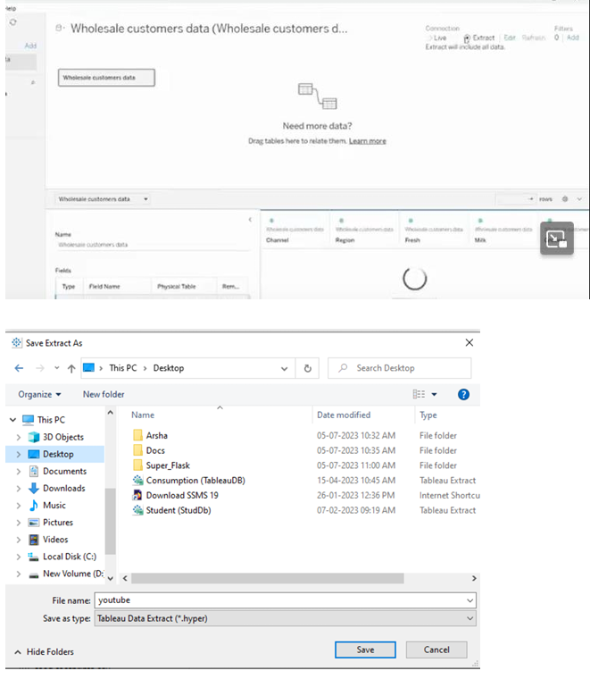

**Step 2**: Go to Dashboard/story, click on share button on the top ribbon

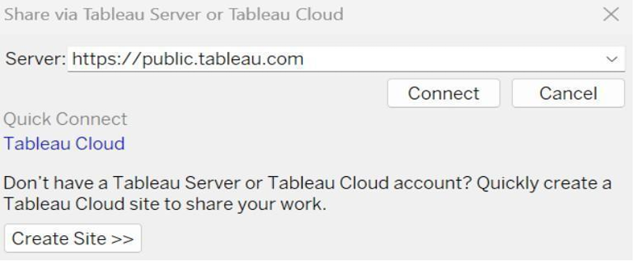

Give the server address of your tableau public account and click on connect.

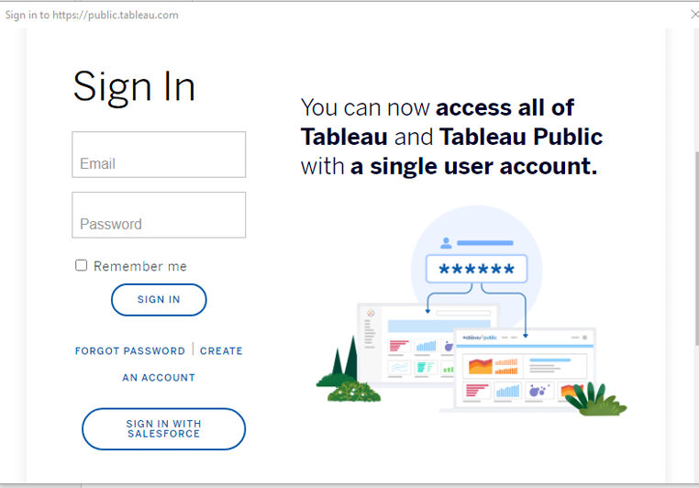

Sign in to your Tableau Public account or create a new account if you don't have one. You can visit the Tableau Public website (public.tableau.com) and click on the "Sign In" or "Join" button.

In the "Tableau Public Sign In" window, enter your Tableau Public account credentials and click "Sign In.

" Next, you'll need to provide a title and description for your workbook. Fill in the appropriate details in the provided field of workbook Title

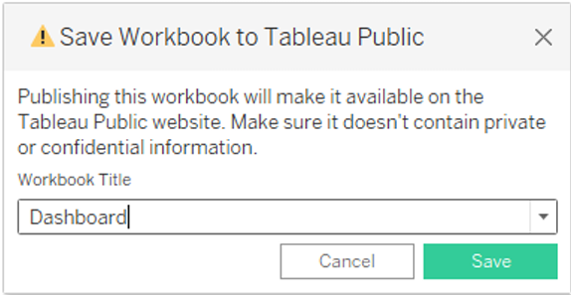

Click on the "Save" button to start the publishing process. Tableau Desktop will upload your workbook to Tableau Public.

Once the upload is complete, a browser window will automatically open, displaying your published workbook on Tableau Public. Review the workbook to ensure that everything appears as expected.

So in Similar way we can also publish Story to tableau public.

**Activity 1: Publishing dashboard and reports to tableau public**

**Team Member 1:**

**Dashboard1:** https://public.tableau.com/app/profile/gopika.r6579/viz/voyagevista/Dashboard1?publish=yes

**Dashboard 2:**

https://public.tableau.com/app/profile/gopika.r6579/viz/voyagevistadash2/Dashboard12?publish=yes

**Story 1:**

https://public.tableau.com/app/profile/gopika.r6579/viz/voyagevistastory/Story1?publish=yes

**Milestone 9: Project Demonstration & Documentation**

Below mentioned deliverables to be submitted along with other deliverables

**Activity 1: Record explanation Video for project end to end solution**

https://drive.google.com/file/d/1cjjGmUGD4IkU3bKi5ikJRYtlpujNaxXT/view?usp=drivesdk

**Activity 2: Project Documentation-Step by step project development procedure**

Create a document as per the template provided.

**4.Advantages & Disadvantages:**

**ADVANTAGES:**

**Uber through E-hail has hired drivers easily and fast. Proprietar software in the app locates drivers circling nearby cheapest carpooling luxury wheels. The price is fixed.**

**Convenient and Cashless**

**Instead of chasing a taxi on a street, or calling and waiting, app users can book a ride from any location and it arrives in minutes.**

**Passenger’s credit or debit card is linked to the taxi app account, no cash changes hands.**

**After the completion of the ride, A receipt is sent via email, and some links to options for rating and tipping the driver.**

**Professional Service**

**Drivers for Uber may use their own cars and bike. Drivers get incentives to keep their taxis clean and well-maintained.**

**The cheapest options for taxis are late-model compact cars and bikes.**

**The riders need to insert their destinations into the app, and the drivers use the taxi app navigational features to reach the rider which is provided by the taxi app development company.**

**The driver talks in a polite and well-spoken manner. Drivers don't get your destination details before picking you up.**

**A driver with a low rating will force a driver out of Uber or its competitors.**

**DISADVANTAGES:**

Drivers are not assured of minimum pay to maintain their own vehicles. This topic is growing controversial in many cities because New York City mandated a $17.22 minimum wage for drivers.

Surge Pricing

“Surge pricing” or “rush time pricing” is not fixed in uber. It’s a free market principle of raising prices according to supply and demand.

This means how many taxis are available (supply) and how many customers want to ride(demand).

This automated system sometimes shows differences in pricing between any two same points.

At peak times, the price could be double or more. This means too costly during rush hour.

Although this benefits uber by increasing the supply of drivers. Drivers can be motivated to earn at this time.

Low Fares WorryDrivers

Some Uber drivers say they struggle to earn minimum wage. Drivers have to pay the cost of fuel, maintenance, and repairs from their own pocket.

With competition from other taxi apps, the earnings of drivers can be driven downward.

This indicates that they need to work for longer hours to earn a certain income.

Price Competition

Uber and other taxi-hailing companies are engaged in an intensive fight to provide the most affordable service.

They are competing with traditional taxi services for both customers and drivers. This has led to low earnings for taxi drivers.

**5.Application:**

1. Estimating expenses is crucial for creating annual, quarterly, or project-specific budgets. This helps in planning how financial resources will be allocated and ensuring that funds are available for necessary expenditures.
2. Businesses use expense estimation to project future financial performance. It aids in predicting revenue, profitability, and potential cash flow issues.
3. Accurate expense estimation allows for proactive cost control measures. By comparing estimated expenses to actual spending, businesses can identify areas where costs can be reduced or optimized.
4. Estimating expenses is essential for setting product or service prices. It ensures that pricing covers all costs and generates a profit.
5. When considering new investments, such as equipment purchases, expansion, or acquisitions, estimating expenses helps evaluate the financial feasibility and potential return on investment.

**6.Conclusion:**

Categorize expenses into fixed and variable costs. This helps in understanding the nature of expenditures and their impact on profitability. Analyze past expense data to identify trends. Are expenses increasing, decreasing, or remaining stable? This can inform budgeting decisions.

Develop a comprehensive budget based on estimated expenses. Ensure that it aligns with revenue projections to maintain financial stability. Identify areas where cost control is essential. Are there any expenses that can be reduced or eliminated without affecting business operations?

Consider how expense estimates influence investment decisions. Will increased expenses lead to greater revenue, or should investments be scaled back? Recognize the importance of setting aside funds for unforeseen expenses. This can be crucial for handling emergencies or economic downturns.

Calculate the impact of estimated expenses on profit margins. Determine if adjustments are needed to maintain desired profitability level. Look for opportunities to improve operational efficiency, which can lead to cost savings and increased competitiveness.

Conclude that expense estimation is an ongoing process. Regularly review and update estimates to adapt to changing business conditions. Conclude that data –driven decisions based on expenses estimates are vital for the long-term financial health of the business.

**7.FUTURE SCOPE :**

Business will increasingly leverage data analytics and artificial intelligence to analyze historical expenditure data, identify patterns, and make more accurate predictions. Machine learning models can assist in forecasting expenses based on various factors, helping companies optimize their budgets.

Automation will play a significant role in expense estimation. Expense management systems and tools will become more advanced, automating tasks such as receipt scanning, categorization, and approval workflows, reducing human error and saving time.

Blockchain can enhance transparency and security in expense tracking. Smart contracts can automate expense approval and reimbursement processes while ensuring the integrity of transactions. With growing awareness of sustainability, business will need to estimate and manage expenses related to eco-friendly initiatives.

This includes investments in renewable energy, waste reduction, and other green practices. Companies expanding internationally will face challenges related to varying tax regulations and currency fluctuations. Advanced expense estimation tools will be required to handle these complexities.

Predictive analytics will become more sophisticated, helping business anticipate expenses in real time. This can be particularly beneficial in managing variable costs. As cyber threats continue to evolve, business will need to allocate resources for cybersecurity measures.